NFL Defensive Ends
Benjamin P. Doyle, Doctoral Student, Department of Kinesiology & Sport Management
John D. Tebbetts, Doctoral Student, Department of Kinesiology & Sport Management

Executive Summary:
This project aims to predict Defensive End success, measured through their draft status and NFL stats, when transitioning out of college football. Traditional scouring and physical testing, at the NFL Combine, offer meaningful insights but could be improved by conjunctive use with both sport analytics / data science approaches. By merging the traditional and new methodologies, we propose that NFL scouts will have a more complete picture of the draft prospects and be better equipped to make effective decisions. Three primary datasets were utilized: NFL Combine, college football production data (stats), and NFL performance culminating in a novel framework to track and predict player success. Methodologies utilized to evaluate this problem were factor analysis, clustering, and predictive modeling.
Factor Analysis revealed four key factors: Power, Momentum, Production, and Change of Direction. Probabilistic clustering separated players into three archetypes: Average, Size-Dominant, and Power-Dominant; Most of the players analyzed fell into the average group however there was no significant defense in the percentage of players drafted from each of these archetypes when considering the NFL draft. Predictive models for draft status exhibited moderate success with Power, Momentum, and Production being significantly associated with success being drafted whereas Change of Direction had little impact on the model. NFL impact score prediction models explained 14-20% of outcome variance, with Momentum and College Performance emerging as the most meaningful predictors. Importantly the reduced model complexity combined with a focus on key features improved accuracy and interpretability validating our approach to this problem.
These findings highlight the value that data driven archetype frameworks and predictive analytics could bring to talent evaluation, draft strategies, and player development. Players seeking to be drafted should prioritize development of Power and Momentum as well as on field performance to increase their draft stock and future NFL success. NFL organizations who integrate transparent interpretable data models in tandem with traditional scouting could benefit from more effective draft strategies, draft decisions, and player development culminating in increased on team performance. While there remains a substantial amount of variance unexplained this project offers actionable insights for optimizing draft selections, developing talent, and strengthening evidence based discourse in the field of sport data analytics.
PROBLEM STATEMENT:
Player success when transitioning from college to the NFL has historically been difficult to predict, the NFL combine seeks to address this issue through a combination of position specific drills and generalized fitness measures; does this predict success though? NFL franchises would benefit from the ability to optimize draft selection and the draft prospects / their coaches would be able to tailor training to optimize draft ability. Therefore, it is the aim of this research to archetype players and investigate which factors are predictive of players being drafted and having success in the NFL. Defensive ends specifically present a unique challenge due to the positional demands, get to the ball behind the line of scrimmage and achieve a tackle for loss (TFL) or sack of the quarterback. Importantly, these players objective can be achieved by utilizing different strategies and taking advantage of unique personal traits, allowing researchers to efficiently archetype the players. By archetyping players owners and draft agents can better understand the players and therefore fill the gaps on their roster. In addition to archetyping players, understanding what tests from the combine and stats from their college careers predict NFL performance allows teams to be more efficient with their draft picks and salary.
DATASETS & PRE-PROCESSING:
Datasets:
NFL Combine Dataset: This project employed three primary datasets. The first and central physical performance-driven dataset was data from the NFL Scouting Combine from 2010-2025, sourced from ProFootball Reference (REF). This dataset contains anthropometric, physical performance, and NFL draft outcome data for approximately 300 players per year (variables are defined in Table A). In addition to the standard physical performance data directly measured at the NFL Scouting Combine, there are two additional variables included in this analysis. Momentum, demonstrated through the 40-yard dash, has been shown to be predictive of starter status as well as long-term performance in collegiate football players (REF). Momentum, the product of a player’s mass and velocity, is reflective of a player’s capacity to both deliver withstand impact, qualities that are extremely important for the DE position. Maximal anaerobic power, calculated through the standing long jump and players body mass, reflects a player’s ability to rapidly apply force across the line of scrimmage into an opposing player. These quantities, taken together, are reflective of a player’s capacity to be strong, fast, and generate forceful impacts, qualities of utmost importance for effective pass rushing. Adding additional calculated variables from validated research allows models to explain a greater degree of physiological/biomechanical performance capacity and enhance interpretability for practitioners (REF). All together, this resulted in a variable set incorporating physical size, speed, change of direction (COD), power, strength, and momentum, along with NFL draft outcomes.
College Football Defensive Statistics: Previous research suggests that data beyond physical performance captured at the NFL Combine is necessary to accurately predict NFL Draft and NFL performance outcomes, regardless of position group (REF). Position-specific skill and college production are likely reflective of athletic prowess beyond physical performance necessary to compete at the professional level. Therefore, college defensive statistics were extracted for as many players as possible to support physical performance outcomes for predicting production in the NFL. Data were scraped from ESPN’s college football data API (REF). To create a sample of players who would be likely to move on to be considered reasonable NFL prospects, only the top 800 players sorted by sacks per season (arguably the primary indicator for an effective pass rusher) per year (2010-2025) were extracted, resulting in several hundred DE’s extracted per year. Note, analyses for the present work were limited to each player’s final recorded season of college statistics, as many players are unable to gain significant playing time prior to their final 1-2 seasons in college (REF). All available college defensive statistics from ESPN were recorded per player, including tackling, pass rushing, and pass coverage statistics, with a summary table of metrics and definitions being listed in Table B.
NFL Defensive Performance Statistics: There have been multitudinous attempts to quantify “success” in the NFL from a statistical standpoint. Previous studies have used total snaps played, games played, contracts signed, or position-specific performance metrics as their “success” metric, however no study has attempted to quantify this specifically for NFL Edge Rushers and DEs (REF). Therefore, we developed a simple score that defines a player’s typical ability to perform a DE’s primary function, making tackles behind the line of scrimmage. Therefore, we defined a player’s impact score as the sum of their career sacks and tackles for loss (TFL) divided by the number of games played. This score was log-transformed to accommodate skewness in the present dataset.
$$IS=log\left(\frac{sacks+TFL}{games played}\right)$$
While defensive ends are often expected to perform tackles of players after they have moved past the line of scrimmage, DEs can directly enhance their team’s chance of causing a turnover on downs more effectively by causing the line of scrimmage to move backwards. Therefore, we considered players who are moving the line of scrimmage in their team’s favor on a more regular basis to be more successful. Data for career sacks, TFLs, and games played were extracted from ProFootball Reference (REF) and merged with the other datasets using SQL keys.
Pre-processing steps:
All data (features and outcomes) were centered and scaled prior to any additional modeling.
NFL Combine Dataset: Across all three datasets employed in this analysis, several steps were taken to ensure that high quality, complete data was used for modeling. The NFL Combine dataset contained a large amount of individuals who were missing at least one test. Of the 357 DEs selected for analysis, 220 were missing at least one raw test metric. It is well-established in coaching circles that these data are not missing at random, as coaches, agents, and individual athletes likely deliberately avoid performing specific tests where they believe they may not perform as well as their peers. This leaves a significant dilemma of whether imputation is an appropriate strategy as it may hypothetically create artificial data that artificially inflates test scores for subjects beyond their true capacity. In previous studies (REF), imputation was deliberately avoided for this reason. In the present study, we elected to perform random forest imputation for NFL combine test scores only in instances where subjects completed at least 3 of the tests, serving as an adequate balance between generating a sufficient dataset to effectively make predictions without overly encouraging artificially inflated scores. All other subjects were removed from modeling steps.
College & NFL Statistics: For the college football statistics, only a player’s final recorded season was retained for modeling. This is because it is expected that the most meaningful contributions to a player’s NFL prospects occur during their final year of college play. Therefore, even for individuals who had recorded defensive statistics over multiple seasons, only their final year was used for modeling. College statistics were considered in absolute terms rather than on a per-game basis, as overall production during the final season of college football was considered a higher priority than per-game performance. NFL impact scores were normalized on a per-game basis as different players may have significantly different career lengths for various reasons. Additionally, predictive modeling was only performed on players who participated in at least 10 NFL games to ensure that players who were those who were actually being included in games.
EXPLORATORY ANALYSIS
Final Datasets: Raw data extraction resulted in a set of 357 eligible players who A) had recorded college stats in their final season, B) participated in the NFL combine, and C) were active in the NFL at any point from 2010-2025. This was then filtered down to 265 players after eliminating players who had not completed at least 3 NFL Combine physical performance assessments.
Exploratory Factor Analysis of Pre-NFL Features:
Rationale: Exploratory factor analysis (EFA) was used to estimate latent performance constructs underlying the pre-NFL dataset by modeling the covariance structure among the observed variables. Our approach was intended to group highly correlated features into factors describing a broader performance construct, enhancing the overall interpretability of these underlying qualities. EFA was selected over other dimensionality reduction tools (specifically principal component analysis) as we intended to explain shared variance among variables rather than total variance within the dataset.
Approach: EFA was performed using a custom Python script utilizing the FactorAnalyzer package. EFA was initially performed without rotation to calculate eigenvalues for between 1-16 factor models. Models with an eigenvalue of at least 1.0 were compared and the optimized model (4 factors) was selected by balancing cumulative explained variance with practical interpretability of the identified factors.
Results: EFA yielded an optimized model featuring four factors which were categorized and interpreted based on the features with the most prevalent loading scores on each factor (Table C). The four factors were categorized as Power, Momentum, Production, and Change of Direction (COD). The Power factor was heavily influenced by the standing long jump and maximal anerobic power features with meaningful loadings from physiologically related tests (vertical jump, 40-yd dash). The Momentum factor was most heavily influenced by body mass and momentum during linear sprinting (p40). The Production factor was characterized by college performance statistics for the DE position’s primary functions, tackles behind the line of scrimmage (sacks, forced fumbles), and tackling (solo and assisted). The COD factor was dominated by average velocity achieved during the 3-cone and pro-agility drills, the primary COD tests at the NFL combine.
Interpretation: These four underlying performance qualities largely align with components expected to meaningfully differentiate physical performance and in-game performance in the DE position, aligning with previous research (REF). Power and Momentum both represent clear, theoretically grounded constructs. Together they describe a player’s ability to rapidly generate force and effectively transfer that force into an opposing player advancing in the opposite direction. Together, these two factors explain 40% of the shared variance in the dataset, suggesting they are effective tools for characterizing physical performance capacity among DEs. Notably, Production (i.e. college tackling performance) explained less shared variance than the physical qualities highly related to tackling ability. Additionally, while zone-style pass coverage has become slightly more prevalent for DE play calling in recent years, the Production factor was minimally influenced by pass coverage metrics (interceptions and passes defended). COD accounted for the least variance among the retained factors, however it remains a meaningful contributor to our understanding of the underlying shared variance for understanding intra-position performance capacity differences. COD abilities are most directly relevant when pursuing targets by moving around offensive linemen, making it a reasonable factor for describing player archetypes and informing predictions for NFL production.
Applications in Additional Modeling: EFA revealed four interpretable factors that collectively provide a coherent explanatory framework for well-established performance qualities relevant to the DE position. These factors offer a solid framework for scouts and coaches seeking to optimize draft selections by understanding the underlying differences between prospects. They subsequently served as the foundation for cluster models used to identify distinct player archetypes based on performance capacity, as well as for constructing interpretable predictive models of NFL performance.
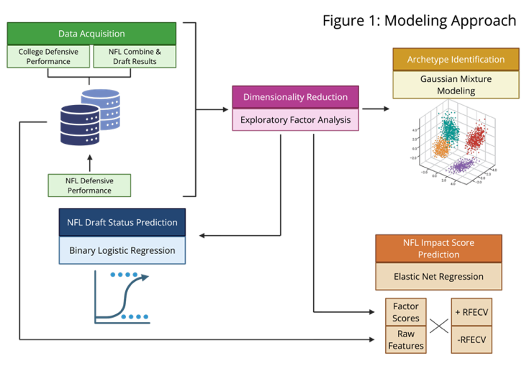
MODELING METHODS:
Descriptive Analysis – DE Archetypes:
Primary Aim: The aim of this modeling stage was to identify a set of DE archetypes that explain some of the heterogeneous play styles that may be observed during a football game. While all DEs share the same position and overall goal, like with any position, individual players may execute their position differently to one another. These models aimed to use clustering methods to group similar players based on the previously defined performance factors (Power, Momentum, Production, and COD) and to understand the prevalence of each of these archetypes among selected players at the NFL draft to explain NFL franchise draft strategy.
Selected Methodology & Rationale: This analysis primarily employed Gaussian Mixture Modeling (GMM) to cluster selected players based on four primary scores calculated via the previously described EFA steps (Supplemental Table C). GMM was selected over alternative clustering methods (e.g., k-means or DBSCAN) as it is a probabilistic approach that assigns players a likelihood score of belonging to each cluster rather than forcing hard group assignments. Probabilistic approaches are generally appropriate for human performance research due to the innate heterogeneity of subjects and unlikelihood that all players will neatly fit into discrete archetypes, meaning GMM accommodates the natural overlap between similar performance profiles in a way that other approaches do not. GMM was applied using the sklearn.mixture GaussianMixture module. The optimal number of clusters was determined by balancing a minimized Bayesian Information Criterion (BIC), the number of players assigned to each cluster, and interpretability for practitioners. Final individual cluster assignments were based on the cluster in which the player had the greatest probability of assignment; however, it is important to note that these assignments are flexible in practice.
Additional Modeling Steps: Several additional modeling and analysis steps were necessary to determine cluster separation, feature importance, and the impact of cluster assignments on the NFL Draft. One-way ANOVA with pairwise T-tests with Bonferroni correction were performed to establish the statistical significance of differences between archetypes. Cluster separation and reassignment stability were evaluated in two ways. Cluster membership probability distributions were used to understand the relative probability of players being assigned to different clusters and existing overlaps for common cluster assignments. Bootstrap stability of cluster assignments (n=1000) was evaluated using an Adjusted Rand Index (ARI). Finally, the frequency of each archetype among players selected at the NFL Draft was calculated for each year from 2010-2025 and a simple OLS regression model was fitted for each to determine if there has been any significant shift in the archetypes being frequently targeted by franchises at the NFL Draft.
Predictive Analysis – NFL Draft Status and NFL Production from Pre-NFL Draft Data:
Primary Aims: This modeling stage had two primary objectives: 1) to validate previously established latent factors as a predictive tool for NFL draft status, and 2) to assess whether these factors and/or raw features could effectively predict NFL career production as measured by “impact score”.
NFL Draft Status: Binary logistic regression (drafted = 1, undrafted = 0) was selected as the primary classification algorithm given its ease of interpretability and suitability for a relatively limited sample size. Two model variants were compared: one trained on raw combine and college performance features, and the other trained on factor scores derived from prior EFA modeling. Both models were trained on an 80/20 stratified train-test split. To obtain stable, distribution performance estimates, each model was evaluated using repeated stratified k-fold cross-validation (500 repeats x 5 folds). This stratification approach was used to handle the class-imbalance seen in the dataset, as a far greater percentage of players in the dataset were in the drafted subclass. The primary performance outcome measures were ROC-AUC and F1 score reported with mean performance and a 95% confidence interval based on the repeated cross-validation. Feature contributions for the best performing model variant were reported to demonstrate each variable’s influence on draft probability and assess the statistical significance of any associations to inform coaches and athletes of relevant training targets.
NFL Player Impact Score: Elastic net regression was used to predict each player’s NFL impact score. Elastic net was selected as the primary modeling tool because it handles multicollinearity well through its combined L1 and L2 penalization approach in a tunable way, allowing the model to adaptively balance feature selection and coefficient shrinkage. As with the draft status models, two feature sets were used: raw features and EFA factors. Each feature set was modeled with and without recursive feature elimination with cross-validation (RFECV). RFECV was included to assess whether iterative feature reduction of minimally important features would improve predictive performance beyond the penalization done via elastic net, serving as a comparison tool for regularization-based and explicit feature selection. All models were trained on an 80/20 train-test split and evaluated across 1000 Monte Carlo iterations using randomized train-test resampling. Monte Carlo simulation was employed due to the continuous nature of the outcome variable and the relatively small sample size, enabling the construction of a distribution of R² values from which mean and variability could be appropriately estimated. Model performance was primarily evaluated using R² to represent the amount of variance in the outcome explained by the model. For the best-performing model for each feature set, elastic net hyperparameters (regularization strength/α and L1 ratio) were reported alongside the corresponding feature coefficient estimates. Permutation importance was calculated post-hoc on each feature set as well to provide a model-agnostic estimate of each variable’s contribution to predictive performance, complementing the coefficient-level interpretability provided by the elastic net models.
MODELING & ANALYSIS:
- DE Archetypes
The GMM identified three distinct performance archetypes among the 265 defensive ends featured in the dataset. Three clusters was selected as the optimal number as it had a BIC similar to the most stable model (k=2) but offered improved practical interpretability. Most players in the dataset (n=201, 75.8%) were grouped into the largest cluster, labelled “statistically average”. Two smaller archetypes emerged which were labeled as “size-dominant” (n=50, 18.9%) and “power-dominant” (n=14, 5.3%). This distribution generally aligned with the expectations for a probability driven clustering approach; however, it is important to note that the power-dominant archetype is very small relative to the others and thus insights should be considered cautiously.
Standardized factors score comparisons between each of the three archetypes revealed clear performance-driven signatures that differentiate each archetype (Table D, Figure 2). The size-dominant cluster demonstrated a substantially elevated Z-score for Momentum (μ=1.72), suggesting these players are broadly characterized by having greater body size and the speed necessary to translate that size into high momentum. The power-dominant cluster exhibited superior performance across the Power (μ=1.12), Production (μ=1.06), and COD (μ=1.31) clusters. As the label implies, the statistically average cluster displayed modest Z-scores across all four factors. All mean differences between cluster centroids for each of the four dimensions were statistically significant (p<0.05).
Cluster assignment confidence varied across archetypes. While the majority of players across all clusters exceeded the 80% membership probability threshold, both the power- and size-dominant clusters contained individuals with notable secondary probabilities of belonging to the statistically average cluster (Figure 3). This pattern suggests some overlap in the performance characteristics between the specialized and average profiles, though a larger sample size may encourage greater cluster separation.
Bootstrap resampling analysis yielded a moderate adjusted Rand Index of 0.558 (95% CI: 0.202-0.803), indicating modest stability in cluster assignment but a very wide range. The wide confidence interval reflects notable variability in cluster reproducibility across resampled datasets, suggesting that the boundaries of these archetypes are somewhat fluid rather than rigidly defined. This finding is consistent with the membership probability distributions and indicates that the three-cluster solution captures overall tendencies rather than absolute categories. This was an expected outcome and serves the purpose of capturing player performance profile tendencies without imposing hard labels on individuals as innate player heterogeneity is a certainty in sport.
Chi-square analysis revealed there were no significant differences in draft frequency among the three archetypes (χ² = 1.244, p=0.537, Figure 4). This indicates that NFL teams select players from each archetype at comparable rates. Further, OLS regression demonstrated no longitudinal trend in archetype-specific draft frequencies (all p>0.05). These findings indicate that archetype classification, as defined by our factor-based clustering methodology, did not meaningfully predict draft selection patterns for the DE position. Archetype assignment also had no significant relationship with NFL impact score, supporting the fact that archetypes have little bearing on actual NFL production without considering extraneous variables like defensive schemes.
- NFL Draft Status
Both logistic regression models demonstrated moderate predictive capacity for NFL draft status, with minimal performance differences attributable to differences in feature selection. The factor score-based model achieved marginally improved discrimination (AUC = 0.709, 95% CI: 0.562-0.839) compared to the raw variable model (AUC = 0.687, 95% CI: 0.534-0.831). While the mean performance was slightly greater in the factor-based model, the AUC distributions of the 2500 cross-validation iterations shows substantial overlap between the two (Figure 5), suggesting that dimensionality reduction via factor analysis only marginally improved prediction quality over raw features.
Both models exhibited similar performance across confusion matrix variables, with the factor-based model demonstrating marginal advantages in specificity, sensitivity, precision, F1 score, and accuracy (Figure 6). Precision was consistently high for both approaches (Factor: 0.87, Raw: 0.87), indicating strong positive predictive value for players being predicted as draftees. Sensitivity, specificity, F1 score, and accuracy ranged between 0.63-0.75 for both models, reflecting moderate but certainly imperfect classification performance. While these metrics suggest that the modest captured meaningful signals relevant to NFL Draft outcomes, a substantial amount of model variance remains unexplained.
The factor-based model coefficients revealed differential contributions of each of the four identified factors toward draft probability (Table E). Three factors demonstrated statistically significant positive associations with draft status Power, Momentum, and Production (all p<0.001). In contrast, COD showed no significant relationship with draft outcomes, indicating that COD-ability explains meaningful variance in the dataset yet does not meaningfully influence NFL team drafting decisions. These findings suggest that scouts and coaches prioritize explosiveness, size, and a history of effective game performance over agility when evaluating draft eligible DEs.
- NFL Player Impact
The four elastic net regression models developed to predict NFL impact score explained between 14-20% of outcome variance (Figure 7). Models utilizing RFECV consistently outperformed their standard elastic net counterparts, demonstrating that systematic feature elimination remains a critical determinant of model performance even when already utilizing a penalized regression approach. While the modest explained variance indicates substantial influence from unmeasured factors (e.g., scheme fit, coaching, injury history, regular opponents, etc.), the models still identified meaningful performance predictors that can distinguish a player’s likelihood of regularly playing a meaningful role in games.
Model A - Factor Scores without RFECV: The factor-based model without RFECV demonstrated competitive performance (R²=0.1798, RMSE=0.7711), nearly matching its RFECV-enhanced counterpart. This similarity suggests that the elastic net penalization effectively reduced non-contributing features without requiring explicit removal. Examining the standardized coefficients revealed that Production (β=0.250) was the dominant contributor to the model’s structure, followed by Power (β=0.186) and Momentum (β=0.174). The COD factor contributed minimally across the simulated models and was frequently reduced to zero (β=0.003; 66.4% reduced to zero) (Figure 8). Permutation importance revealed a slightly nuanced pattern, showing that Power exhibited the greatest model-agnostic contribution to predictive performance, followed closely by Momentum then Production (Figure 9). This discrepancy between coefficient magnitude and permutation importance suggests that while Production explains more shared variance in the fitted model, Power carries more unique predictive information for individual players. Production’s larger coefficient may reflect its connection to other meaningful constructs, whereas Power and Momentum provide a more independent signal pertaining to a player’s physical performance capacity.
Model B - Factor Scores with RFECV: RFECV yielded a modest overall performance improvement (R²=0.1897, RMSE=0.7665) by systematically removing the influence of the COD factor (Figure 7). This result confirms that COD contributed no meaningful predictive signal and potentially contributed to model overfitting. This removal both reduced model complexity and improved predictive accuracy, demonstrating that Power, Momentum, and Production provide more predictive value and additional test scores from the NFL Combine may not be necessary to make meaningful predictive inference.
Model C - Raw Features without RFECV: The raw variable model without RFECV exhibited the poorest performance of all models (R²=0.1452, RMSE=0.7872), likely reflecting overfitting due to the relatively high feature-to-sample ratio (Figure 7). Despite the elastic net’s regularization reducing the coefficients for less informative variables, the model struggled to effectively separate signal from noise across the selected features. Coefficient analysis revealed that solo tackles, momentum, anaerobic power, height, and weight had the largest weight on the model, while other features were substantially penalized (Figure 8). No clear conceptual pattern emerged among the moderately-weighted features, suggesting that the model captured scattered signals rather than clear performance dimensions. Permutation importance analysis provided a more clear interpretation of the model. Solo tackles, momentum, and anaerobic power (the dominant features of the Production, Momentum, and Power components, respectively) clearly had the greatest isolated influence on the model’s performance (Figure 9). Interestingly, bench press repetitions exhibited negative permutation importance, indicating that this variable actively degraded model predictive capacity. This finding is counterintuitive for a test designed to measure upper body strength, but supports previous research suggesting that the NFL 225-lb bench press is an adequate test of local muscular endurance rather than strength, indicating that the test is minimally informative for athletes with already high strength (REF). Ultimately, the bench press test simply reflects a large amount of performance variance in the dataset without necessarily informing any meaningful predictive insight for tackling effectiveness in the NFL.
Model D - Raw Features with RFECV: The RFECV model achieved the best overall performance (R²=0.2000, RMSE=0.7616), though it performs only marginally better than both factor-driven models (Figure 7). This finding demonstrates that appropriate feature selection of raw variables can enable raw variables to match or slightly exceed the predictive capacity of dimensionality-reduced factor scores. This is particularly valuable as this model required only two raw features (momentum and solo tackles) to make high quality predictions regarding a player’s potential in the NFL. This parsimonious solution indicates that a simple two-variable framework consisting of a player’s momentum and collegiate tackling production effectively captures most of the explainable variance which can be obtained using the current modeling structure. This dramatic reduction from 16 to 2 features suggests that most combine and college production metrics provide redundant information or contribute statistical noise rather than enhancing our understanding of a player’s performance potential. Both retained features demonstrated substantial coefficients with comparable magnitudes and permutation importance, with solo tackles demonstrating a slightly greater isolated contribution to momentum (Figure 8, Figure 9). The convergence between coefficient magnitude and permutation importance in this model indicates that both features provide unique predictive signals, ultimately serving as a simple, effective, interpretable framework for effectively predicting NFL performance.
KEY VISUALIZATIONS & INTERPRETATIONS:
All tables and figures are displayed in the supplemental pages of this document. Several visualizations are especially useful for interpreting the results of this study and we recommend readers use this figures to further contextualize the results when considering the applications of these findings and interpretability for practitioners.
Table C presents the complete exploratory factor analysis results, including the factor loadings for all combine and production metrics across the four derived factors used throughout the analysis. The table uses a heat map style (red = positive, blue = negative) to aid with interpretation. The table provides the overall foundation for interpretation of the underlying constructs existing within the performance-driven dataset to enable users to understand how the raw performance test results extracted from the NFL Combine and college performance aggregate into unified constructs.
Figure 2 directly compares factor scores across the three identified archetypes, illustrating the distinct performance profiles of average, size-dominant, and power-dominant players. While archetype assignment was not meaningfully predictive of either draft status or NFL impact scores, this visualization helps contextualize potential on-field roles and tactical applications for players within each profile in the context of an NFL roster, particularly for the specialized size- and power-driven archetypes.
Figure 5 and Table E summarize the classification performance and feature contributions of the binary logistic regression models aimed at predicting NFL Draft status. These materials demonstrate model discrimination capacity over the 2500 iterations of the model and identify which performance factors significantly influenced draft probabilities.
Figures 8 and 9 display the elastic net regression coefficients and permutation importance values, respectively, revealing which predictors drive model performance (coefficients) and which ones are independently impactful for predicting NFL performance (permutation importance). As demonstrated specifically with models B and D, the best performing factor- and raw feature-driven models, parsimonious approaches using the three factor scores or two raw features provided optimal predictive capacity while maximizing interpretability. While model performance is certainly important for understanding the quality of these models (Figure 7), understanding the features that most directly contribute to meaningfully predicting NFL outcomes provides practitioners far more straightforward frameworks for player evaluation without requiring complex multivariate modeling.
CONCLUSIONS:
Archetyping
Probabilistic clustering of performance factors (Power, Momentum, Production, and COD) caused three primary archetypes to emerge among NFL Defensive Ends: Average, Size-Dominant, and Power-Dominant. The average group accounted for 75.8% of players analyzed; this archetype presents as moderate scores across all four factors reflecting their well-rounded but unspecialized athletic profiles. Size-Dominant players accounted for 18.8% of players analyzed: players within this archetype exceled in both their physical stature as well as their momentum measurements. Lastly, Power-Dominant players accounted for only 5.3% of players analyzed; this archetype was characterized by superior power, college performance, and change of direction indicating they possess advanced athletic traits and technical proficiency while on the field (Figure 2). Cluster assignment probabilities were robust with most players assigned at greater than 80% however as with any human based measurement there was overlap due to the existence of “freak” athletes and hybrid players. Bootstrap analysis of assignment stability (Adjusted Rand Index, ARI=0.56; 95% CI = 0.20–0.80) further highlights that archetype borders are not sharply defined, aligning with the probabilistic nature of human performance. Analysis of draft frequency revealed no significant differences in selection rates between the varying archetypes nor any trend in draft preference over time.
The NFL as a complete organization does not seem to discriminate between archetypes suggesting that the archetype assignment does not drive league wide draft decisions and should instead be used by individual teams to identify players who fill gaps in the roster. These findings reinforce the complexity of talent evaluation in football where teams are likely to, and should continue to, take qualitative information beyond college and combine results into account when drafting players. This archetype framework may be interpreted as a useful framework for allowing athletes and practitioners to identify performance strengths or areas of need for improvement toward developing a better overall athletic profile, however these findings are purely descriptive at this stage and have no meaningful influence on NFL Draft outcomes.
Draft Status
Both logistic regression models performed similarly, with the factor score based on slightly outperforming the raw feature mode (AUC = 0.709 vs. 0.687, respectively), indicating modest improvement in discriminatory capability through dimensional reduction. Confusion matrix analyses reflected these findings: positive predictive value (PPV) for draft status was strong (>0.8) in both models, with other classification metrics—sensitivity, specificity, F1 score, and accuracy—consistently ranging from 0.6 to 0.75 (Figure 6). Analysis revealed that three latent factors: Power, Momentum, and Production were significantly associated with an increased likelihood of being drafted. These findings in combination with previous literature reinforce the practical value of combining physical performance with effectiveness and that neither alone means an individual is the right pick for the NFL. Uniquely, this approach of adding performance data has meaningfully improved the model’s predictive ability and explained variability (REF Doyle et al.).
COD was not significantly predictive of draft status which is expected since it is a skill that does not impact on field performance in DEs as much as other positions. The models demonstrated robust predictive ability compared to previous research (REF), but a substantial proportion of variance (~80%) in draft outcome remained unexplained. This gap likely reflects qualitative parts of the draft process such as interviews, team needs, injury history, or psychological factors. Our findings support a data-driven approach for both player preparation and organization decision making during the draft. Players aiming to be drafted should prioritize development of power and momentum, which would be expected to enhance their college production, enhancing their draft ability.
NFL Impact Prediction
Across all four models the explained variance was modest ranging from 14-20%, although these R² values scientifically have a weak positive relationship when put into the unique context of football this R² is far more predictive than previous (published) models. Across all the models the predictive power was moderate-to-strong when considering previously published data attempting to predict NFL draft or NFL performance outcomes from the Combine/college performance statistics. Although in literal terms these models explain a relatively small amount of variance, when considering the massive heterogeneity that exists among individuals in terms of physiological and biomechanical performance and skill execution under pressure, explaining a meaningful percentage of this variance suggests that the modeling offers relevant predictive insights. Momentum and college tackling performance were the most meaningful features for predicting of NFL impact scores. This approach suggests that simple modeling approach utilizing minimal features, aligned selected for the specific position group, may be the most useful for predicting outcomes as seen in the comparison between models C and D. Additionally the minimized numbers of factors has limited the model from overfitting data and allowed the model to perform with similar accuracy when new data is added.
These predictive models offer insights to owners, coaches, and players allowing them to understand which metrics may be predictive of NFL success and therefore should be prioritized during player development and scouting. The unique benefit of this modeling approach is that the model can be adjusted for owners and coaches based on their schematic preferences and organizational priorities. Incorporation and utilization of supervised machine learning models could assist scouts in evaluating talent therefore allowing them to take a deeper look into each potential draft pick to make a better prediction of a player’s potential and their fit into the scheme. This allows the organizations to use predicted NFL Impact Score as a potential metric for evaluating draft picks, providing them an increased level of insight into player potential and additional data to consider when making their draft selections; Identification of effective high value players in would allow for more efficient use of draft selections in both the early and late rounds.
Benefits & Limitations of the Modeling Approach
Rather than focusing on only traditional scouting or only statistical modeling we are suggesting a hybrid approach that takes methodology from sport analytics and data science while still allowing the freedom to adjust the model based on the requirements or priorities of a specific team. By doing this the technical nuance of player performance can be analyzed accounting for the unique advantages a traditional statistical model would wash out. Employing factor analysis has allowed for the identification of known underlying performance traits such as power and momentum and clustering of players; Clustering is a necessary step in the evaluation of talent because it provides coaches with a background for talent evaluation and which current NFL player this player’s potential future should be compared to, accounting for the complexity and heterogeneity of individual differences and performance. The combination of data from multiple sources allowed players to be tracked longitudinally across their development, this unique trait allowed us to link college performance and physical traits to NFL on field success. We chose to prioritize transparency and interpretability, focusing on methods that would be accessible to both researchers and sport professionals; therefore, our findings can be readily applied to actual drafting decisions, player development, and broader talent identification through both the draft and free agency market. This project encouraged evidence-based discourse related to societal challenges and limitations of current scouting practices. By making analytics-based models more interpretable and adaptable based on the client we have empowered a wider range of stakeholders to benefit from this work: from players seeking to be drafter to staff making decisions about who to draft, to fans who want a better understanding of why their favorite team drafted player X instead of player Y.
An inherent issue with modeling human performance is the individual variability within the dataset, there are certain limitations to our approach. The use of artificial physical performance data carries an inherent risk of inflating test performance scores and the small amount data available for this position limits the sophistication of modeling approaches that can be used. Conversely however the benefit is highly interpretable models, such as logistic regression and elastic net, rather than black box models, such as neural networks. Related to the sample size there is also an inherent effect on the archetyping due to the limited size of certain clusters, specifically the power-dominant one. Future analysis should utilize larger datasets to broaden the overall size of each cluster.
RECOMMENDATIONS:
For NFL Draft Prospects and Their Support Staff
Prospective players aspiring to high draft value and NFL success should prioritize training focused on the three primary factors most highly related with NFL draft status and performance (Power, Momentum, and Production). By optimizing training prescription to enhance test performance in these areas and increase the number of tackles and sacks a player manages in college, this may enhance a player’s probability of being selected in the draft and may encourage NFL franchises to offer them higher draft picks and contract value. That said, the predictive models only explain a modest amount of draft outcome variance and impact score variance, therefore players should still focus on holistic physical and skill development and regularly demonstrate that they have unique “X-factor” capabilities in games to account for factors which may not be explained in these models. Lastly, sustained development throughout a college career, culminating in their final collegiate season likely increases the overall impact of a player’s final season, therefore encouraging players to limit transfers in a system that allows them growth rather than transferring every year if the final goal is an NFL career.
For NFL Owners, Coaches, and Scouts
The use of data driven archetype frameworks may help contextualize a player’s strengths and allow a team to enhance archetype diversity to promote players who can serve different roles based on the opponent or play-call – avoiding over-reliance on a single archetype of DE that may leave the defense weaker in certain situations. Understanding a player’s performance archetype may encourage teams to develop more complex playcalling and allow for novel strategic development. Predicted vs actual impact score may also be a valid measurement tool for evaluating a player’s performance over time, allowing teams to determine whether a player was a draft bust and performed poorly in the NFL. Predictive models for NFL impact scores may enable teams to begin to understand a player’s potential future performance, however these interpretations must be made cautiously with the understanding that there are multitudinous factors which may impact a player’s eventual impact on defensive play in the NFL. Although we strongly believe these models could benefit NFL franchises, they should always be utilized in conjunction with qualitative assessment such as interviews and scheme fit to make organizational decisions. Rookies who maintain or exceed predicted impact score should likely be retained as they are likely continue their growth and increase in on field performance according to the model.
SUPPLEMENTAL TABLES & FIGURES:
Table A: NFL Combine Dataset Variables
Variable | Definition
Ht_IN | Height in inches (in)
Wt_LB | Body weight (lb)
40Y_VEL | 40-yard dash average velocity (m/s) (distance/time)
3CD_VEL | 3-cone drill average velocity (m/s) (distance/time)
PROA_VEL | Pro agility drill average velocity (m/s) (distance/time)
VJ_IN | Vertical jump height (in)
SLJ_IN | Standing long jump distance (in)
BENCH_REPS | Number of bench press repetitions (225 lb) until failure
P40 | Average momentum during the 40-yard dash (kg*m/s)
SLJP | Maximal anaerobic power (calculated via formula from Mann et al., 2021).

Table B: College Football Dataset Variables
Variable | Definition
TACKLES_SOLO | Completed tackles without assistance from a teammate
TACKLES_ASSISTED | Completed tackles with assistance from a teammate
SACKS | Completed tackles of the quarterback/passer behind the line of scrimmage
FORCED_FUMBLES | Instances where the defensive player knocks the ball out of the opponent’s possession resulting in a live ball
PASSES_DEFENDED | Instances where the defensive player prevents a pass completion by deflecting the ball
INTERCEPTIONS | Instances where the defensive player catches a pass intended for an opponent

Table C: Exploratory Factor Analysis Loadings & Explained Variance
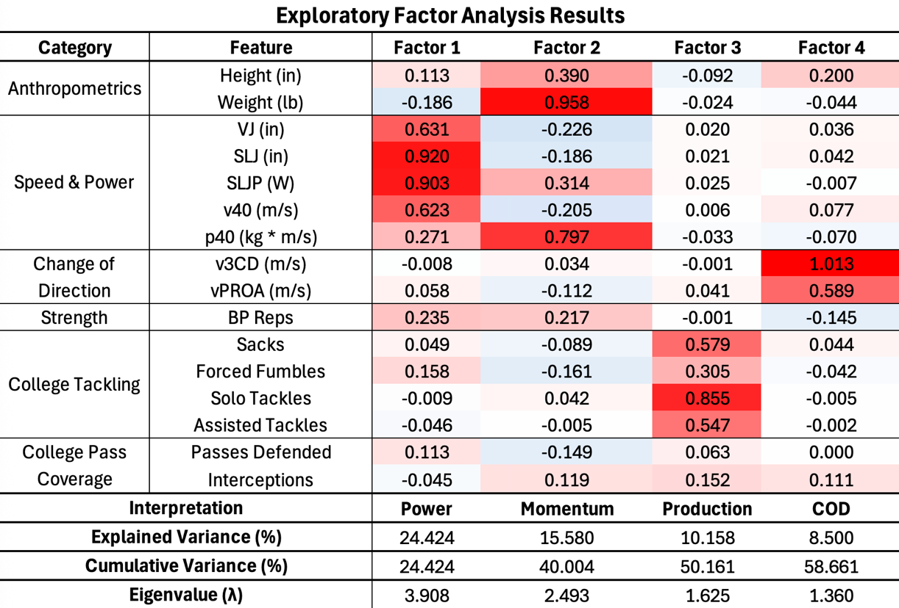
VJ = vertical jump height; SLJ = standing long jump distance; SLJP = standing long jump power; v40 = 40-yard dash average velocity; v3CD = 3-cone drill average velocity; vPROA = pro-agility drill average velocity; p40 = momentum during the 40-yard dash; BP = 225-lb bench press

Figure 1: Modeling Approach
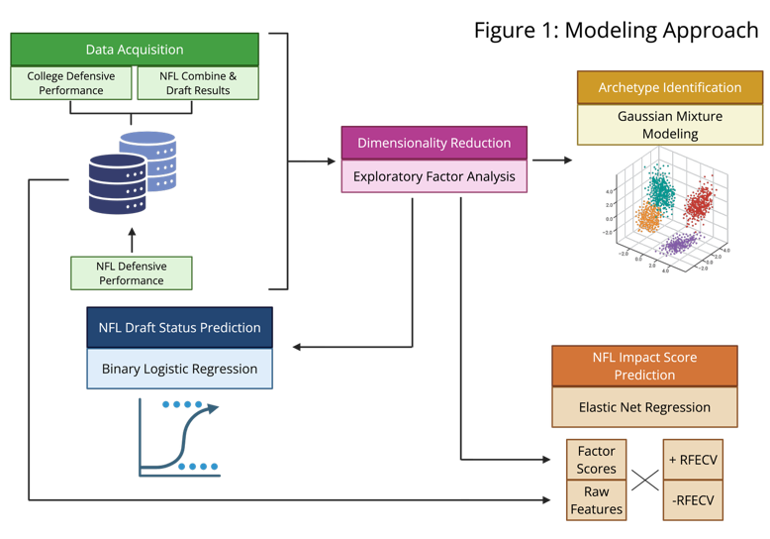

Table D: Archetype Factor Score Summary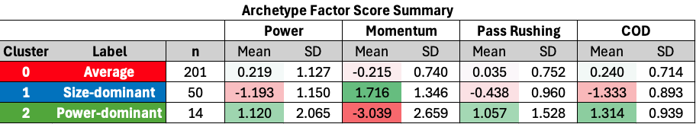
Mean z-scores of each cluster across each of the four components. SD = standard deviation. COD = change of direction.

Figure 2: Archetype Assignment Comparisons Across Identified Factors
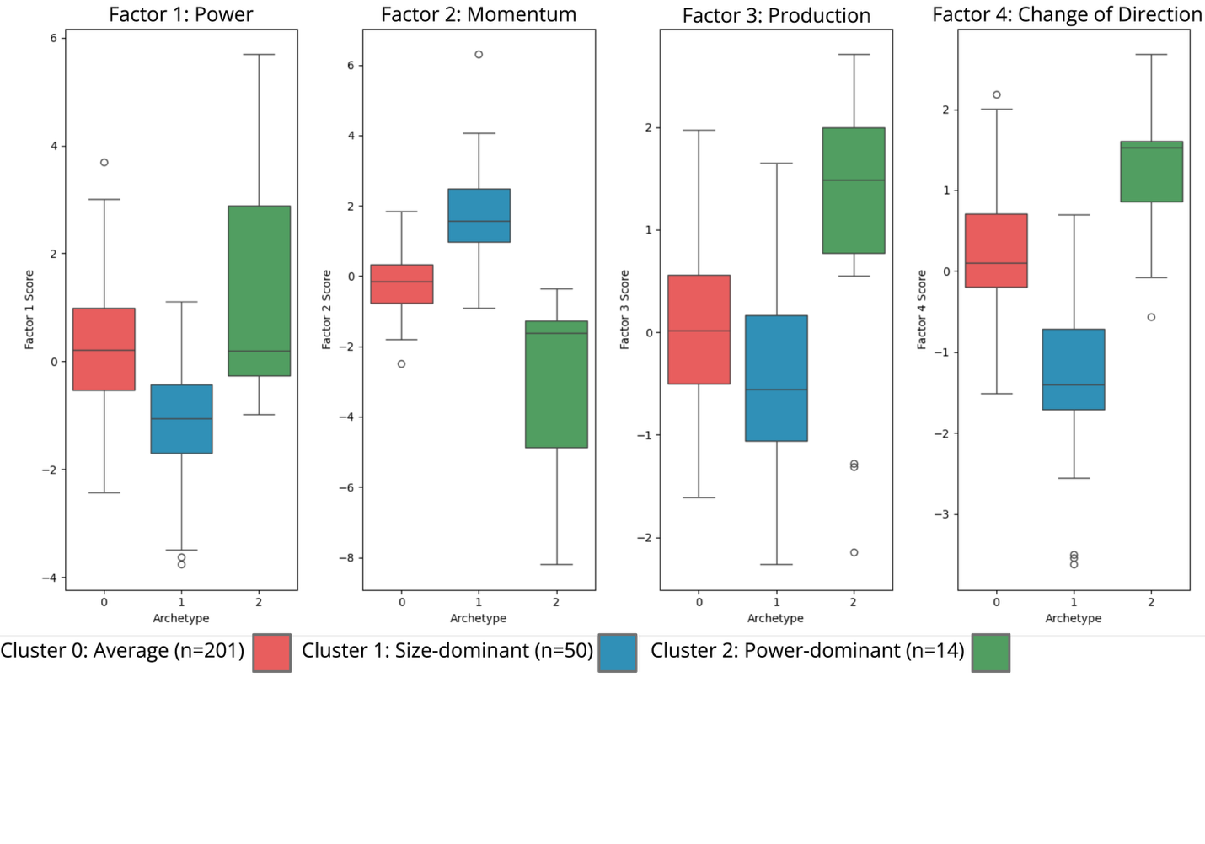
Factor scores refer to the standard and scaled z-score for each factor. Hollow circles represent individual outliers.

Figure 3: Cluster Assignment Probability Distributions & Bootstrap Resampling Stability
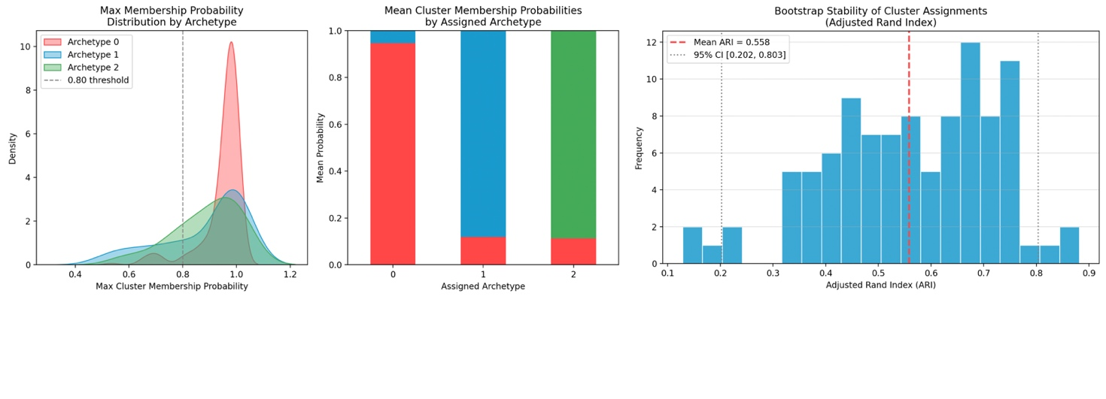

Figure 4: Average NFL Draft Frequency and Impact Score by Archetype Assignment
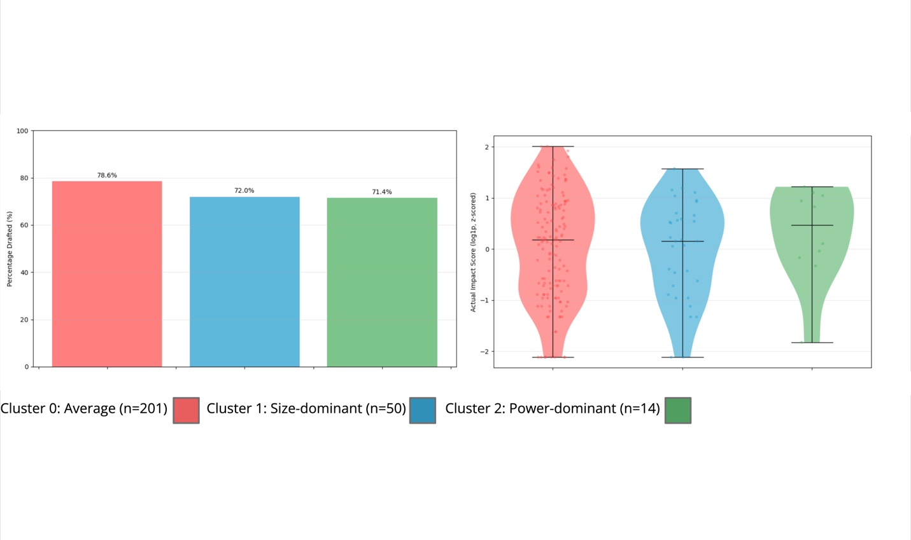
There were no statistically significant differences between clusters regarding draft status (χ² = 1.244, p=0.537) or impact score (H=0.85, p=0.653).

Figure 5: ROC-AUC Probability Distribution for Binary Logistic Regression Models predicting NFL Draft Status
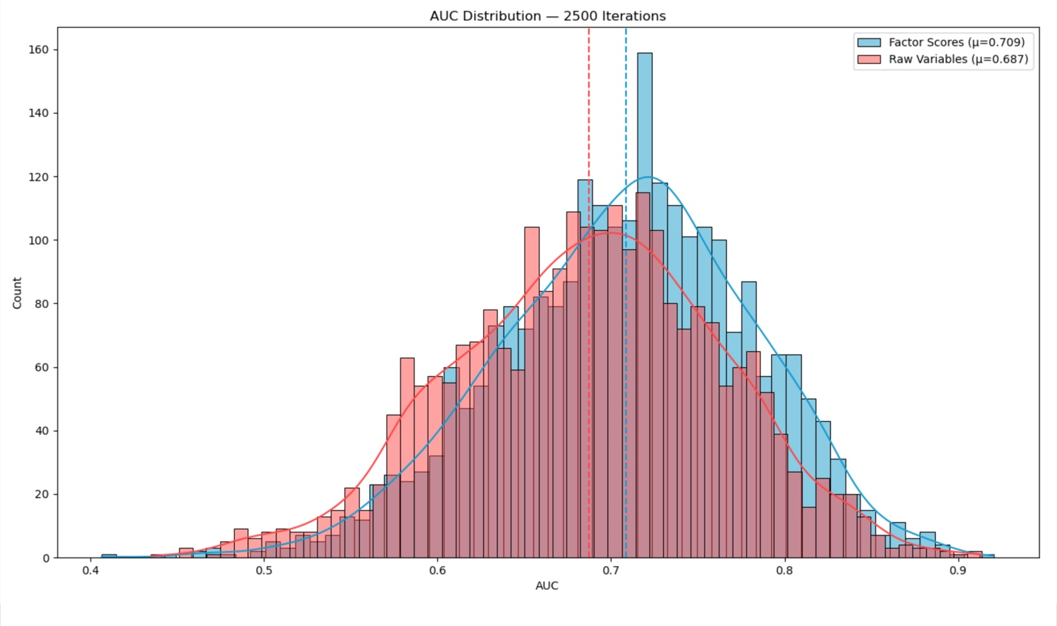
Figure 6: Binary Logistic Regression Confusion Matrix Results
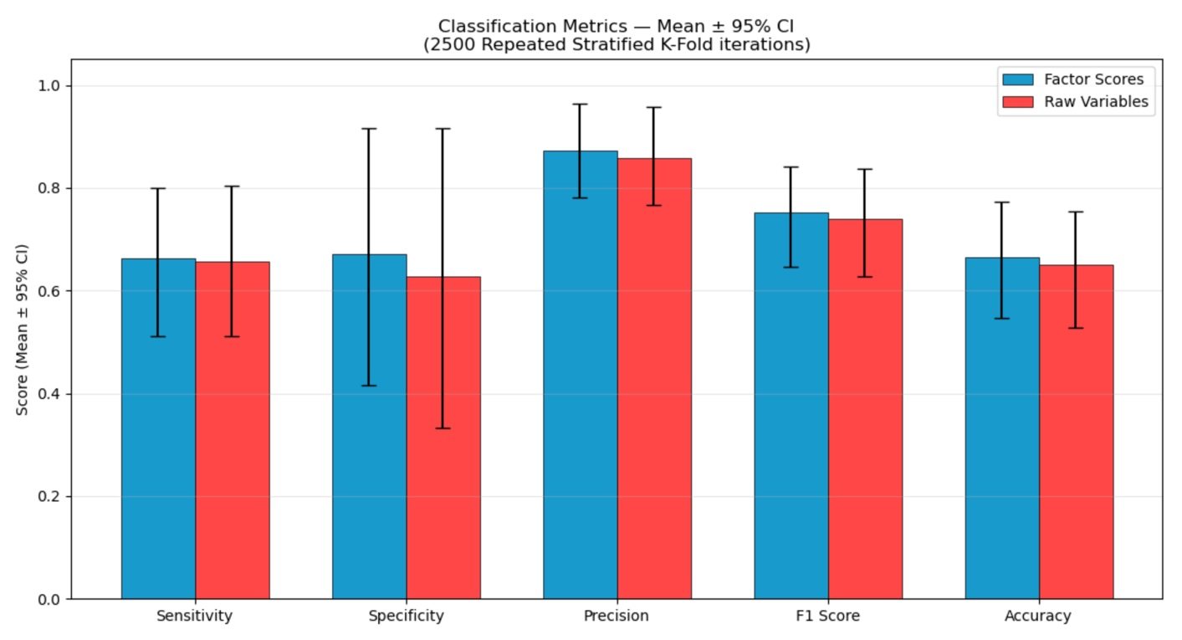

Table E: Binary Logistic Regression Model Summary
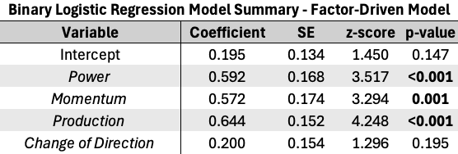
SE = standard error; bold p-values denote statistically significant associations between the factor and increased NFL Draft probability.
Figure 7: Predicted vs Actual Elastic Net Model Performance for Predicting Impact Score
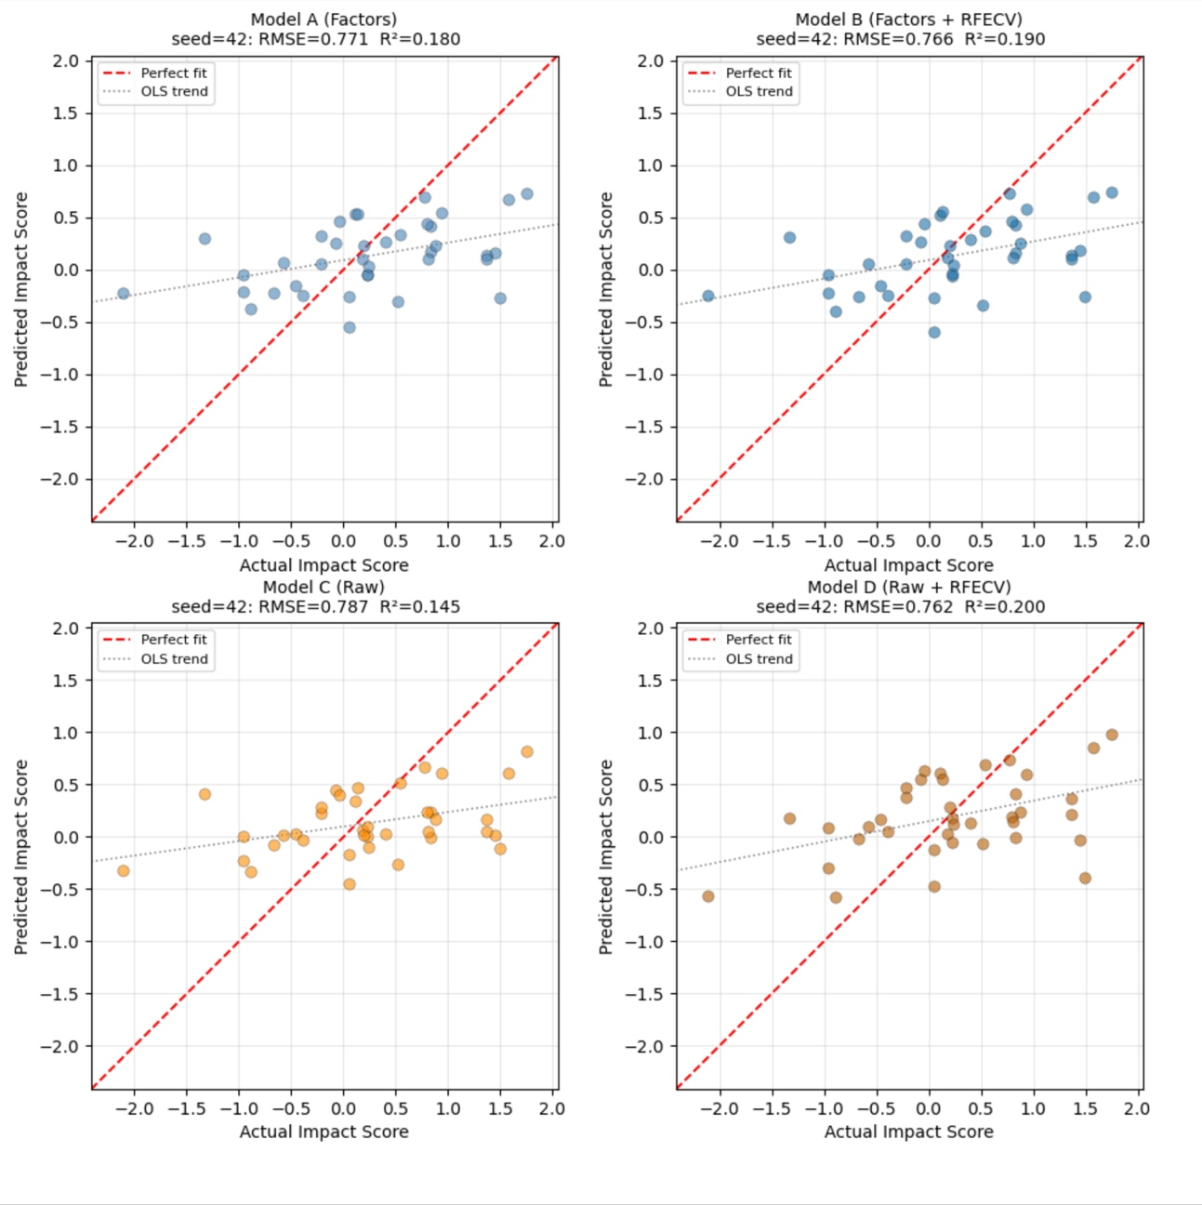

Figure 8: Elastic Net Model Coefficients
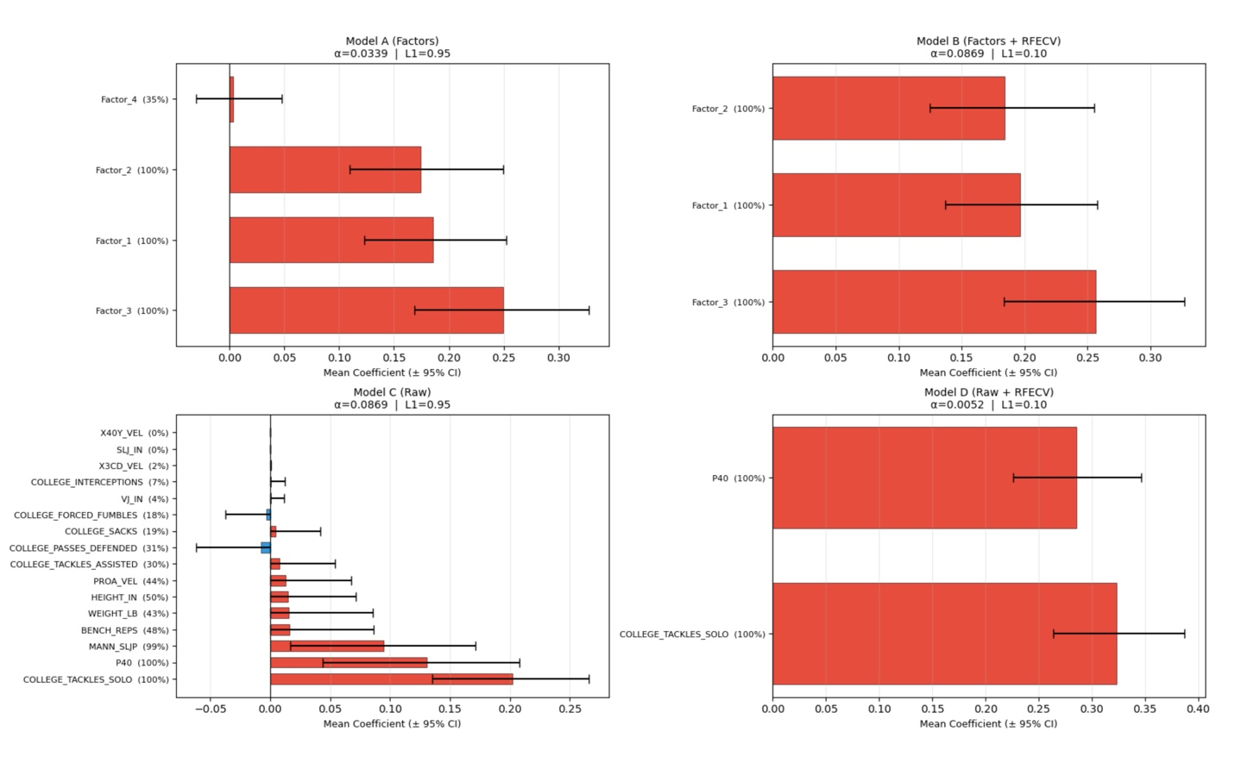
Bars represent the mean ± 95% CI after 1000 Monte Carlo iterations. The % value denotes the number of iterations where the coefficient for a given variable was non-zero. RFECV = recursive feature elimination with cross-validation.

Figure 9: Elastic Net Model Permutation Importance
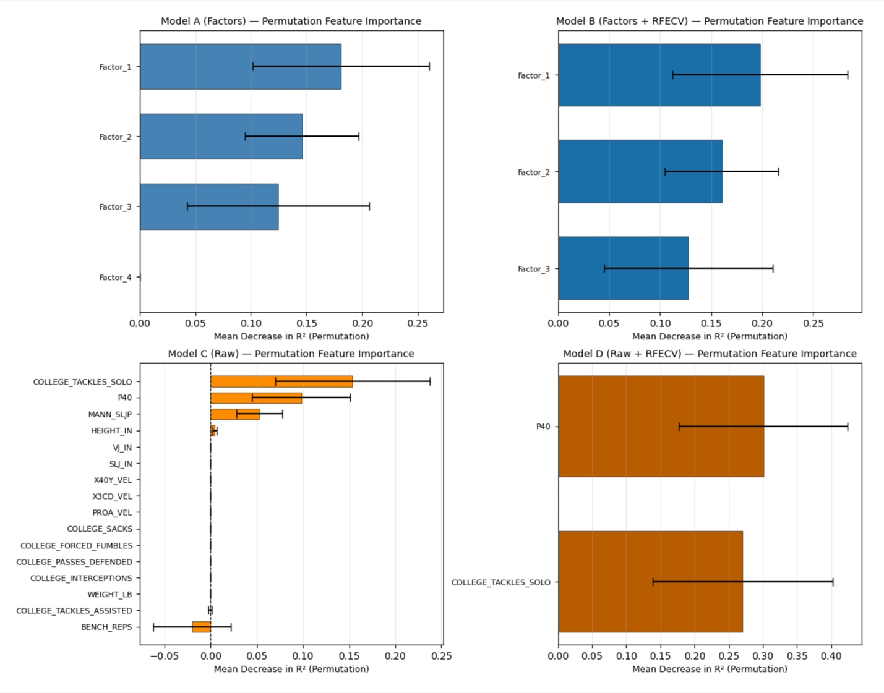
Bars represent the mean ± 95% CI after 1000 Monte Carlo iterations. RFECV = recursive feature elimination with cross-validation.

REFERENCES:

